VISVESVARAYA TECHNOLOGICAL UNIVERSITY
Jnana Sangama, Belagavi – 590 018.

A GENAI PROJECT REPORT
on
“Multi Document RAG Chatbot”
Submitted by
DHANUSHREE S (1VI23CD013)
JAHANAVI M (1VI23CD017)
SIRI M (1VI23CD055)
JEEVIKA REDDY K (1VI23CD018)



DEPARTMENT OF COMPUTER SCIENCE AND ENGINEERING (DATA SCIENCE)
VEMANA INSTITUTE OF TECHNOLOGY
BENGALURU – 560034
2025 - 26
ABSTRACT

Organizations and individuals often deal with large volumes of documents such as PDFs, research papers, and reports, making it difficult to extract relevant answers quickly using traditional search tools. This project presents a Multi Document RAG (Retrieval-Augmented Generation) Chatbot that leverages large language models (LLMs) and semantic search techniques to answer natural language queries accurately from multiple uploaded documents. The system processes documents by splitting them into chunks, generating vector embeddings, and storing them in a vector database for efficient retrieval. When a user submits a query, the system retrieves the most relevant document chunks using semantic similarity and passes them as context to the LLM to generate a precise, grounded response. The platform integrates a user-friendly chat interface that supports uploading multiple file types including PDF and DOCX, real-time question answering, and source document referencing. Additionally, the system emphasizes accuracy, contextual understanding, and scalability, making it suitable for students, researchers, legal professionals, and enterprises. By enabling conversational access to document knowledge, this solution aims to democratize information retrieval and make document-based insights accessible to a broader audience.

Keywords:
Retrieval-Augmented Generation, Large Language Models, Vector Embeddings, Semantic Search, Document Chunking, Natural Language Processing, Conversational AI

TABLE OF CONTENTS
ii
TITLE | PAGE NO.
ABSTRACT | i
TABLE OF CONTENTS | ii
LIST OF FIGURES | iii
INTRODUCTION | 1
- SYSTEM REQUIREMENT SPECIFICATIONS | 3
RESULTS AND DISCUSSIONS | 6-7
CONCLUSION AND FUTURE SCOPE | 8

LIST OF FIGURES

TITLE | PAGE NO.
Fig. 3.1: Document Upload and Management Interface | 6
Fig. 3.2: Chat and Document Analysis Interface | 7
Fig. 3.3: RAG-Based Answer Generation from Uploaded Document | 7
iii
CHAPTER 1

INTRODUCTION
1.1 Project Overview
The Multi Document RAG Chatbot is designed to enable users to interact with multiple documents through a conversational interface powered by Retrieval-Augmented Generation (RAG). The system allows users to upload several documents simultaneously and ask natural language questions, receiving accurate answers grounded in the content of those documents. Traditional keyword-based search tools often fail to understand context and intent, making them inefficient for complex document exploration.
The proposed system processes uploaded documents by segmenting them into manageable chunks, converting them into vector embeddings using pre-trained language models, and storing them in a vector store for semantic retrieval. When a user poses a question, the system identifies the most contextually relevant chunks and feeds them to a large language model (LLM) to generate a well-informed, coherent answer. This ensures responses are always grounded in the actual document content.
A user-friendly interface built with Streamlit allows users to upload multiple documents, ask questions in natural language, and receive contextually accurate answers with source references. The system aims to provide clear, trustworthy responses by citing the exact document sections used. Overall, the project focuses on making document knowledge accessible and interactive through intelligent conversational AI.

1.2 Problem Statement
Organizations frequently manage large collections of documents such as research papers, technical manuals, legal contracts, and reports. Extracting specific information from these documents using traditional keyword search is time-consuming, inaccurate, and fails to understand the semantic meaning of queries. This creates a significant barrier for users who need quick and accurate answers from their document repositories.
Additionally, general-purpose chatbots lack access to private or domain-specific documents, limiting their usefulness for specialized queries. Users are forced to manually read through multiple files to find relevant information, which is inefficient and error-prone.
With the rapid growth of digital documentation, there is a pressing need for an intelligent system that can automatically understand, retrieve, and synthesize information from multiple documents and deliver accurate, context-aware answers in a conversational manner.

1.3 Proposed Solution
The proposed solution is a Multi Document RAG Chatbot that utilizes machine learning and data analysis techniques to uncover complex relationships in financial datasets. The system begins by preprocessing the stock data, including data cleaning, normalization, and handling missing values to ensure accuracy and consistency.
These embeddings are stored in a vector database, enabling fast semantic similarity search at query time. When a user submits a question, the top relevant chunks are retrieved and passed to an LLM along with the query to generate a grounded, accurate response. The system also integrates a clean chat interface built with Streamlit, allowing users to upload documents, ask questions, and receive source-referenced answers. By automating document retrieval and response generation, the system reduces manual effort and significantly enhances information accessibility and usability.

1.4 Project Objectives
• To develop an intelligent multi-document question answering system using Retrieval-Augmented Generation (RAG) techniques.
• To reduce manual document reading effort by enabling users to query multiple documents through a natural language chat interface.
• To preprocess uploaded documents by performing text extraction, chunking, and embedding generation for efficient retrieval.
• To support multiple document formats including PDF and DOCX and enable simultaneous querying across all uploaded files.
• To apply semantic search and large language models for accurate, context-aware answer generation from document content.
• To display source references alongside generated answers so users can verify and trace information back to the original document.
• To provide a user-friendly Streamlit interface that allows users to upload documents and interact through a conversational chat window.

CHAPTER 2

SYSTEM REQUIREMENT SPECIFICATIONS

2.1 Technical Architecture
The system follows a lightweight, modular, and scalable architecture designed to efficiently process and retrieve information from multiple uploaded documents. It adopts a client–server model, where the Streamlit application serves as the frontend chat interface and connects to backend modules implemented in Python. The architecture is divided into multiple stages, including document upload, text extraction, chunking, embedding generation, vector storage, semantic retrieval, and LLM-based answer generation, allowing each component to function independently and efficiently.
The system processes documents through structured pipelines, ensuring smooth data flow from document ingestion to answer delivery. The preprocessing module handles tasks such as text extraction, sentence-aware chunking, and embedding generation using transformer-based models. The retrieval module examines semantic similarity between the user query embedding and stored document chunk embeddings using cosine distance in the vector store.
The LLM module receives the retrieved chunks as context and generates a precise, grounded natural language response to the user’s query. The architecture ensures efficient computation, seamless interaction, and real-time conversational response. This design guarantees flexibility, scalability, and high performance, making it suitable for future enhancements in multi-modal document understanding and enterprise-grade deployment.

2.2 Technology Stack
- Frontend Technologies:
The frontend is developed using Streamlit, providing an interactive and user-friendly chat interface for uploading multiple documents and submitting natural language queries. It supports real-time message display, document upload controls, and source reference panels for smooth and intuitive interaction.

- Backend Technologies:
The backend is implemented using Python, which handles document ingestion, text chunking, embedding generation, and retrieval logic. Libraries such as LangChain are used for building the RAG pipeline, PyMuPDF and python-docx are used for document parsing, and FAISS or Chroma is used as the vector store for efficient similarity search.
- Visualization Tools:
OpenAI GPT or open-source LLMs such as LLaMA or Mistral are integrated via the LangChain interface to generate context-aware answers. HuggingFace Sentence Transformers are used to generate dense vector embeddings from document chunks and user queries.
- Development Tools:
Visual Studio Code is used for coding and debugging, while Jupyter Notebook may be used for experimentation, prompt engineering, and testing retrieval and generation pipelines.
- Compatibility:
The system is compatible with Windows, macOS, and Linux environments. It runs on any modern web browser through Streamlit’s web-based interface, ensuring broad accessibility and ease of use without requiring specialized client software.

2.3 Dataset Used
The system is designed to work with user-uploaded documents in formats such as PDF and DOCX, containing any type of textual content including research articles, technical manuals, legal documents, and reports. While academic papers and enterprise documents can be utilized for demonstration and evaluation, the system is not limited to any specific domain or topic. It automatically extracts text, identifies document structure, and performs chunking and embedding generation accordingly. This flexibility allows the platform to adapt to diverse knowledge domains and ensures broader usability across academic, legal, medical, and enterprise use cases.

2.4 Techniques Used
• Retrieval-Augmented Generation (RAG) for grounded and accurate answer generation from document context
Document preprocessing (text extraction, sentence-aware chunking, and overlap management for coherent retrieval)
• Vector embedding generation using pre-trained Sentence Transformer or OpenAI embedding models
• Semantic similarity search using FAISS or Chroma vector store with cosine distance metrics
• LLM-based response generation using GPT or open-source language models via LangChain
• Conversational chat interface with source document citation and multi-turn dialogue support

CHAPTER 3

RESULTS AND DISCUSSIONS

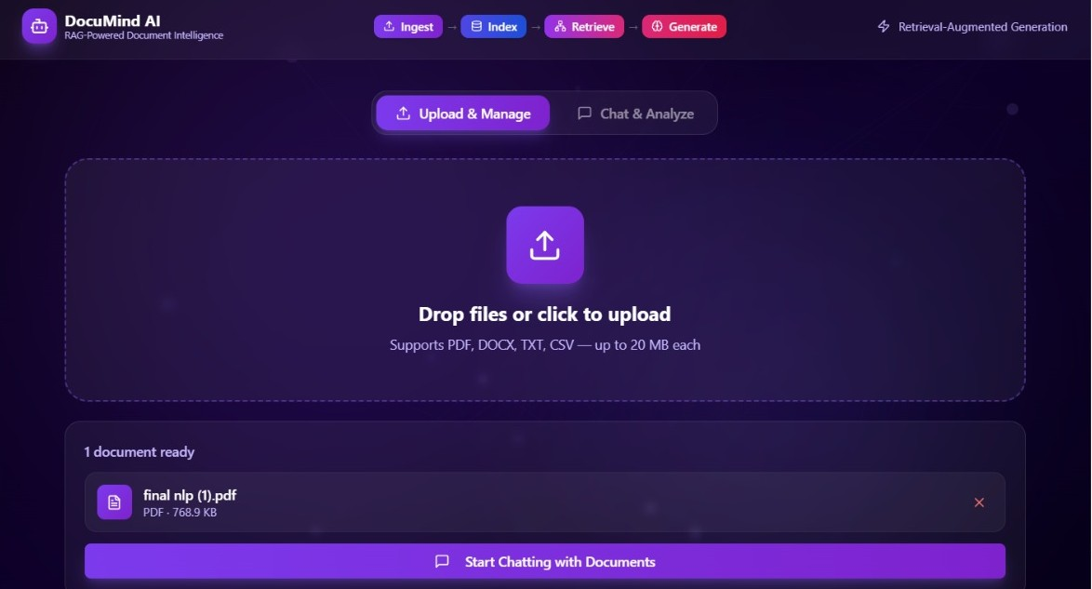

Fig. 3.1: Document Upload and Management Interface
Figure 3.1 shows the Document Upload and Management Interface of the Multi Document RAG Chatbot (Docu Mind AI). It allows users to upload documents in formats such as PDF, DOCX, TXT, and CSV (up to 20 MB each) through a simple drag-and-drop or click-to-browse panel. Once uploaded, the document is listed with its name and size, confirming it is ready for analysis. A "Start Chatting with Documents" button navigates the user to the chat interface for querying.

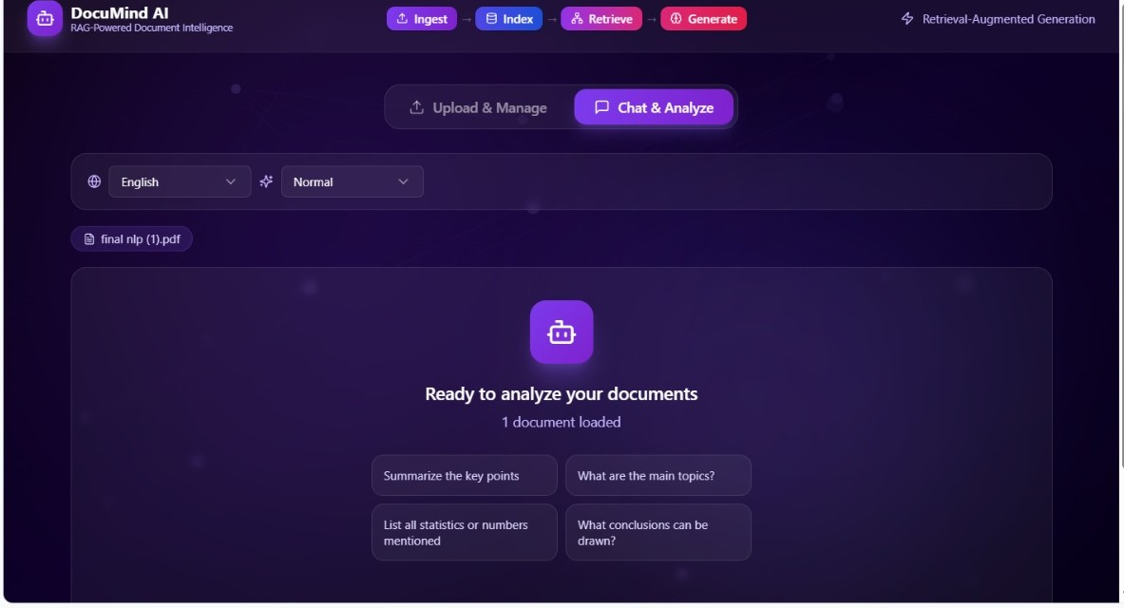
Fig. 3.2: Chat and Document Analysis Interface
The Figure 3.2 shows the Chat and Analyze Interface of the Multi Document RAG Chatbot. After the document is successfully loaded, the system displays a ready state confirming "1 document loaded." Users can select the response language and complexity level, and are presented with suggested query prompts such as "Summarize the key points," "What are the main topics?," "List all statistics or numbers mentioned," and "What conclusions can be drawn?" to help initiate document analysis quickly.
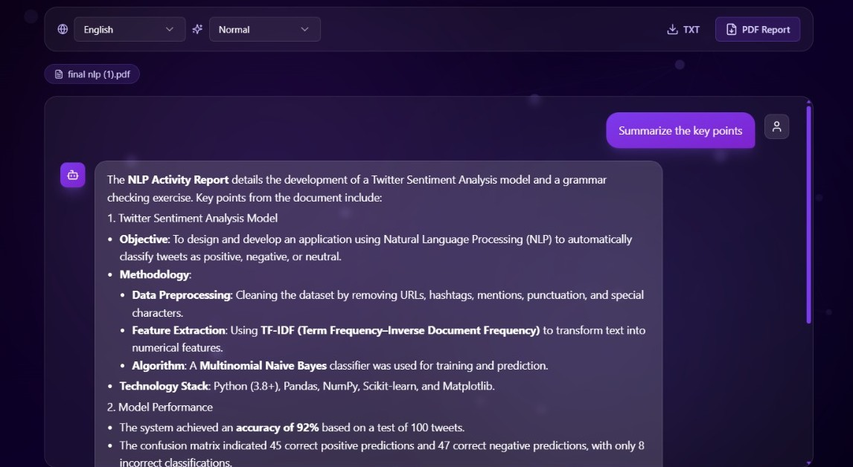Fig. 3.3: RAG-Based Answer Generation from Uploaded Document
Figure 3.3 shows the answer generation output of the Multi Document RAG Chatbot. When the user submits the query "Summarize the key points," the system retrieves relevant chunks for the uploaded document and generates a structured, context-accurate response using language model.

CHAPTER 4

CONCLUSION AND FUTURE SCOPE
The Multi Document RAG Chatbot provides an effective solution for analyzing complex financial data by identifying hidden relationships among multiple variables. By combining semantic search and large language model capabilities, the system delivers accurate, context-grounded answers to user queries without requiring manual document reading. It reduces information retrieval effort, minimizes response time, and enhances the accessibility of document knowledge. The system also ensures source transparency, scalability, and ease of use through its automated RAG pipeline and intuitive chat interface, making it suitable for students, researchers, legal professionals, and enterprise teams.
Despite its effectiveness, there are several opportunities for future improvement. The system can be enhanced by incorporating support for additional file formats such as Excel, HTML, and scanned image-based PDFs using OCR. Integrating memory and multi-turn conversation history will allow the chatbot to maintain context across follow-up questions for a more natural dialogue experience. Additionally, adding a document summarization feature will help users get an overview of uploaded content before asking specific questions. Support for multilingual documents and queries can expand usability to non-English speaking users. Further enhancements such as role-based access control, cloud-based vector storage, and fine-tuned domain-specific LLMs can make the platform more robust, secure, and accurate for enterprise-grade deployment.

